CS-322 Software Construction

SRS DOCUMENT:( finance tracking system)


Project Management System

PRESENTED BY

GROUP NO(G17)
MEMBER 1:BIBI RABBIA (GROUP LEADER)
MEMBER 2 :HUMAIRA NADEEM (ABSENT)
MEMBER 3:FATIMA ANUM(ABSENT)
USE C ASE :
Bibi rabbia(user authentication ,edit/delete transaction,view report)
Fatima anum(add category,add transaction ,add savings)
Humaira Nadeem(view transaction history,view graph,modified savings)

SUPERVISED BY
Dr. Onaiza Maqbool

Department of Computer Science
Quaid-e-Azam University, Islamabad
Project Plan Document Approval Signatures
Project Manager
______________________ _______________________
Signature Date

Bibi rabbia
Student, QAU Islamabad
Member 1
______________________ _______________________
Signature Date

Humaira nadeem
Student, QAU Islamabad
Member 2
______________________ _______________________
Signature Date

Fatima anum
Student, QAU Islamabad

Member 2
______________________ _______________________
Signature Date

Dr. Onaiza Maqbool
Professor, QAU Islamabad

Table of Contents:
1. Introduction 2
1.1 Purpose 2
1.2 Document Conventions 2
1.3 Intended Audience 2
1.4 Project Scope 3
2. Overall Description 3
2.1 Product Perspective: 3
2.2 Product Functions 3
2.3 User Classes and Characteristics 4
2.4 Operating Environment: 4
3.System Features 4
3.1 Feature description: 4
3.2 Functional requirements: 5
3.3 Use Case diagram : 5
4. External Interface Requirements 6
4.1 User Interfaces 6
4.2 Hardware Interfaces 6
4.3 Software Interfaces 6
5. Non-Functional Requirements 6
6. Other Requirements 7
7.Reference 7
Appendix a — Glossary 7
Appendix B — References 7
Revision History: 8

FIGURE :
Figure 1: Use Case Diagram of the Finance Tracking System
Figure 2: SSD for UC-1 — User Authentication
Figure 3: SSD for UC-2 — Add Transaction
Figure 4: SSD for UC-3 — Edit/Delete Transaction
Figure 10: SSD for UC-9 — View Reports
Figure 7: SSD for UC-6 — View Graph
Figure 6: SSD for UC-5 — Add Savings Goal
Figure 5: SSD for UC-4 — Add Category
Figure 8: SSD for UC-7 — View Transaction History
Figure 9: SSD for UC-8 — Modify Savings Goal
Figure 11: Domain Model
Figure 12: Sequence Diagram
Figure 13: Collaboration Diagram

1. Introduction:
1.1 Purpose:
The purpose of the document is to explain the requirements and features of the system i.e. finance tracking system. The system is designed to help the users to manage their daily income and expenses. It provides an easy method to record transactions, view financial reports, and analyse spending money and also good for saving.
1.2 Document Conventions:
FR-x is used for functional requirements.
NFR-x is used for non-functional requirements.
1.3 Intended Audience:
The intended audience of this system are:
- Developers:
They are responsible for implementing what the system should do and ensuring it does not perform actions beyond its defined scope.
• System Tester:
System tester prepares and applies test cases to check whether the requirements of the project are fully meet or not.
• Instructor:
Instructors are those which evaluate the design quality and completeness.
• End Users:
People finally use the system and understand how the system work and meet the personal financial needs.

1.4 Project Scope:
The Personal Finance Tracking System allows users to record their income and expenses. It aims to help users maintain a balanced budget and achieve their saving goals. The system provides graphs to make data visibility simple and clear. It also provides the facility of notification or alert when budget limit is exceeded.
2. Overall Description:
2.1 Product Perspective:
The Finance Tracking System will be a standalone desktop application. User will store their income information and finances category MYSQL database. This system allows users to manage their finance records .The system will not require an internet connection for normal operation.
2.2 Product Functions:
Requires user registration and login confirmation
Adding income or expense transactions
Categorizing expenses (food, bills, rent, etc.)
Set the budget limit and give notification or alert when budget limit is exceeded.
Generating reports and graphs
Viewing summaries by week, month or year
Managing saving goals and viewing progress
Adding categories for organizing transactions
Viewing previously recorded transaction history
Modifying existing savings goals
2.3 User Classes and Characteristics:
In this system there are two types of users that link with this system:
Registered users:
These users directly interact with finance tracking system to manage their expenses.
Administration:
Role of administration is optional because if users allow the administration to manage the users account for smooth functionality otherwise users manage it by yourself.
2.4 Operating Environment:
OS: Windows/Linux
Language: Java
Database: MySQL
IDE: Net Beans / Eclipse
3 : SYSTEM FEATURES:
3.1:FEATURE DESCRIPTION:
- User Authentication:
Users can register an account.
Users can log in and log out.
Add Transaction:
Users can add income or expense transactions.
Users can enter amount, category, and date.
Edit/Delete Transaction:
Users can modify or delete existing transactions.
Add Category:
Users can add categories for transactions.
Add Savings Goal:
Users can create a new savings goal.
View Graph:
Users can view graphs based on financial data.
View Transaction History:
Users can view previously recorded transactions.
Modify Savings Goal:
Users can update an existing savings goal.
View Reports:
Users can view weekly financial reports.
3.2:FUNCTIONAL REQUIREMENTS:
Feature ID | Feature Name | Functional Requirements
FR-1 | User Authentication | FR-1.1 User can create an account.  FR-1.2 User can log in and log out.
FR-2 | Add Transaction | FR-2.1 User can enter transaction type.  FR-2.2 User can select category and date.  FR-2.3 System saves the transaction.  FR-2.4 System updates the total balance.
FR-3 | Edit/Delete Transaction | FR-3.1 User can update or delete existing transactions.
FR-4 | Add Category | FR-4.1 User can add a category for transactions.
FR-5 | Add Savings Goal | FR-5.1 User can create a savings goal.
FR-6 | View Graph | FR-6.1 System displays graphs based on available financial data.
FR-7 | View Transaction History | FR-7.1 System displays previously recorded transactions.
FR-8 | Modify Savings Goal | FR-8.1 User can update an existing savings goal.
FR-9 | View Reports | FR-9.1 System displays weekly reports.
3.3 :USE CASE DIAGRAM:
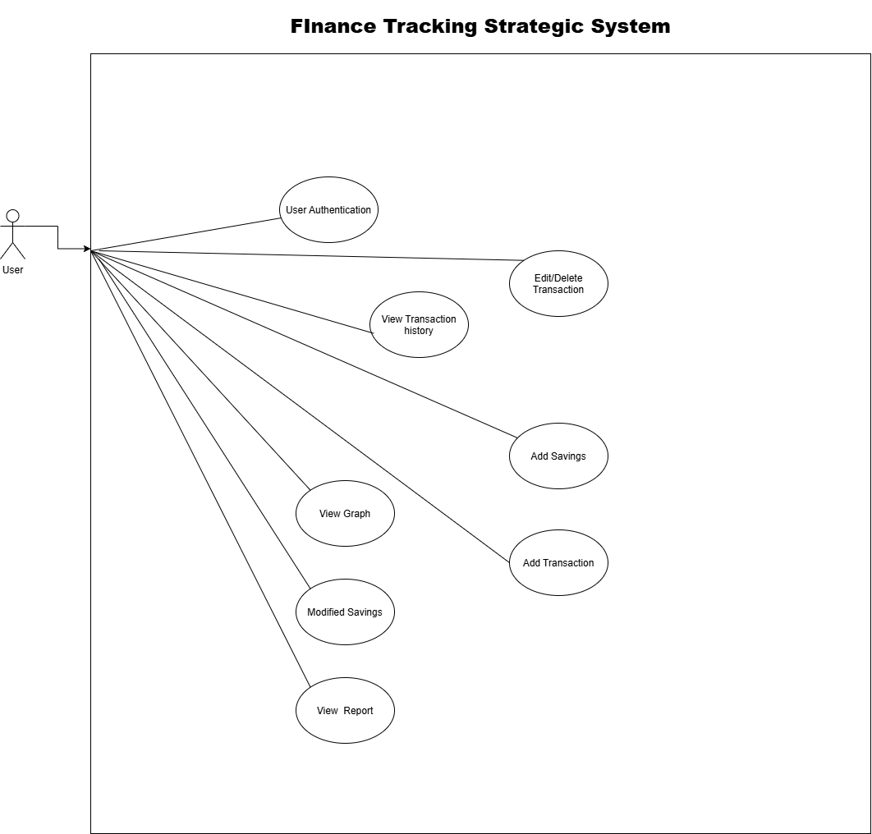

- USE CASES (DESCRIPTION)
- FR-1: User Authentication(bibi rabbia)
- Actor: User
- Pre-Conditions:
- The application must be installed and running.
- For login, the user must already have a registered account.
- Post-Conditions:
- A new user account is created or
- The user is successfully logged in/logged out.
- Main Success Scenario:
- The user opens the application.
- The user selects "Create Account."
- The user enters personal details.
- The system validates information.
- The system creates the account.
- The user enters login credentials.
- The system verifies the credentials.
- The user is granted access to the system dashboard.
- Alternative Flows:
- A1: Invalid Registration Information
- The system detects missing/incorrect fields and shows an error.
- A2: Incorrect Login Credentials
- The system displays “Invalid username or password”.
- Inputs: Personal details (name, email/username, password) for registration; login credentials (username/email, password)
- Outputs: "Account created successfully" message; dashboard displayed after login; error messages ("Invalid username or password" / missing or incorrect fields error)

USE CASE:2
ADD TRANSCATION :(Fatima anum)
Actor: User
Pre-Conditions:
- The user must be logged in.
- At least one category must be available for selection.
Post-Conditions:
- The transaction is stored in the database.
- The total balance is updated accordingly.
Main Success Scenario:
- The user selects “Add Transaction.”
- The user chooses the transaction type (Income/Expense).
- The user enters the amount.
- The user selects a category.
- The user enters or selects the transaction date.
- The system validates the entered information.
- The system saves the transaction.
- The system updates the total balance.
- The system displays a confirmation message.
Alternative Flows:
- A1: Invalid Amount
  - The system displays an error message and asks the user to enter a valid amount.
- A2: Category Not Selected
  - The system asks the user to select a category.
- A3: Invalid or Missing Date
  - The system displays an error message and asks the user to enter a valid date.
- A4: Invalid Transaction Information
  - The system rejects the transaction and asks the user to correct the entered information.
Input/Output
Input:
- Transaction Type
- Amount
- Category
- Date
Output:
- Transaction saved confirmation
- Updated total balance

USE CASE 3:(bibi rabbia)
EDIT/DELETE TRANACTION:
(system sequence diagram):

UC 3

USE CASE 4:ADD CATEGORY(Fatima anum)
(system sequence diagram)

USE CASE 5:ADD SAVINGS:(Fatima anum)
Sequence diagram
USE CASE 6:VIEW GRAPH:(humaira Nadeem)
System sequence diagram

USE CASE 7 :VIEW TRANSACTION HISTORY:(humaira Nadeem)
SYSTEM SEQUENCE DIAGRAM

USE CASE 8:MODIFIED SAVING:(humaira namdeem)
System sequence diagram

USE CASE 9:VIEW REPORTS:(bibi rabbia)
Actor: User
Pre-Conditions:
- The user must be logged in.
- At least one transaction must exist in the system.
Post-Conditions:
- The selected financial report is displayed to the user.
- The system data remains unchanged.
Main Success Scenario:
- The user selects the "View Reports" option.
- The user chooses a reporting period (Weekly, Monthly, or Yearly).
- The system retrieves the financial data for the selected period.
- The system generates the report based on that data.
- The system displays the report to the user.
Alternative Flows:
- A1: No Records Available
  - If there are no transactions in the selected period, the system displays the message "No data available."
- A2: Report Generation Failed
  - If the system cannot generate the report, it shows an error message and asks the user to try again.
Inputs:
- Reporting period ( Monthly )
Outputs:
- Financial report (total income, total expenses, savings, and category-wise summary; add a graph if your system shows one)
- The message "No data available" or an error message if the report cannot be generated

Use case 3:edit/delete transaction :
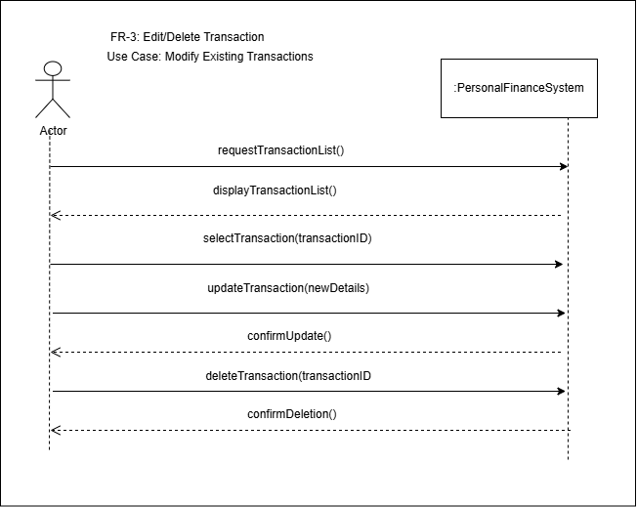

USE CASE 4:add category:
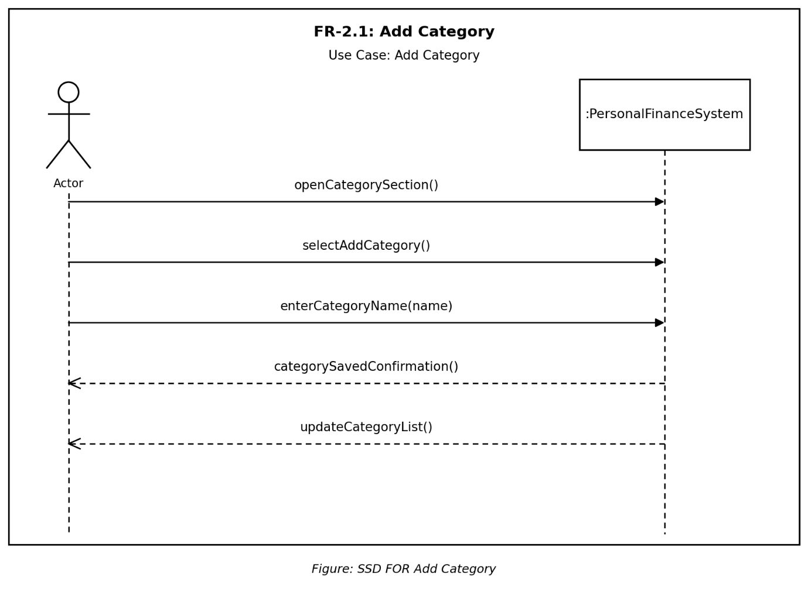

Use case 5: add savings
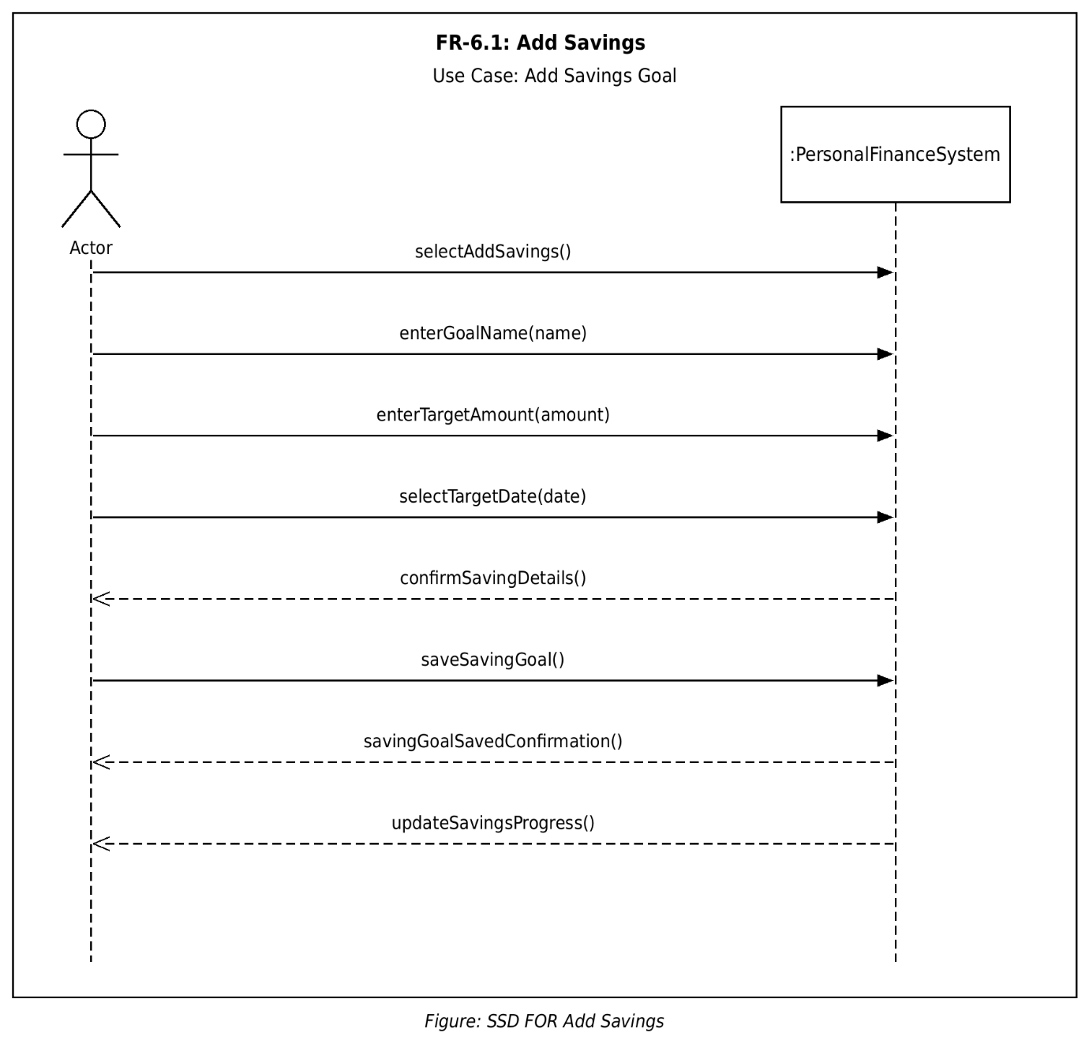

Use case 6:
View graph:
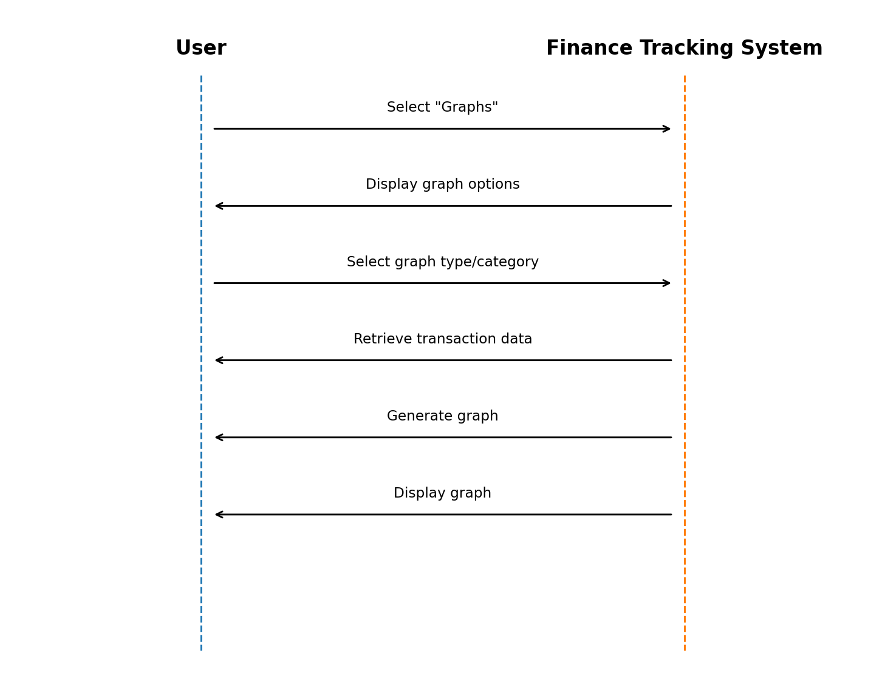

USE CASE 7:VIEW TRANSACTION HISTORY
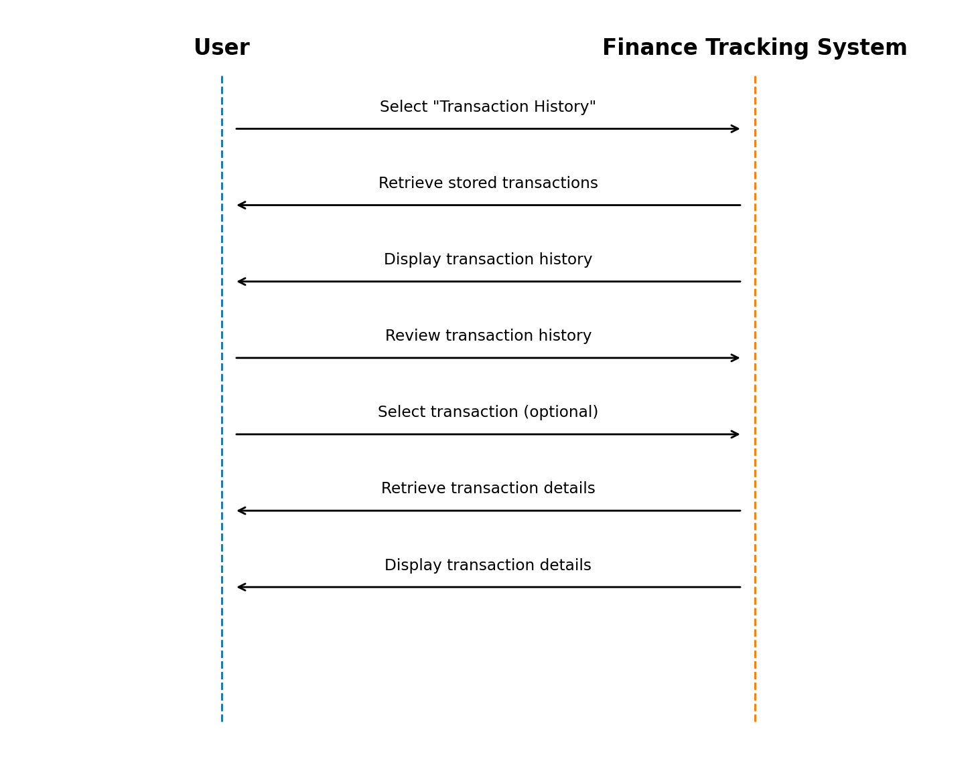

Use case 8:modify savings:
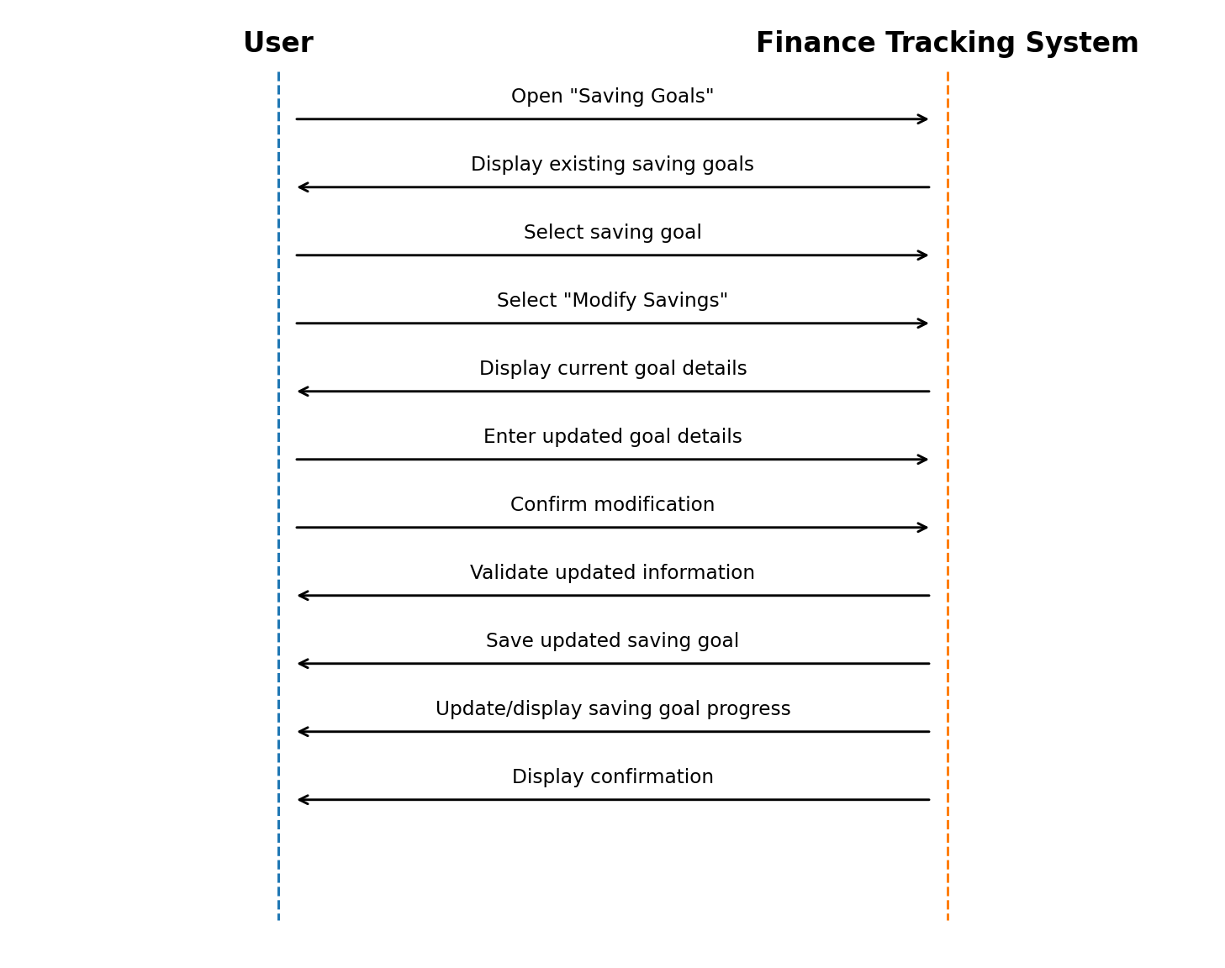

Domain Model:
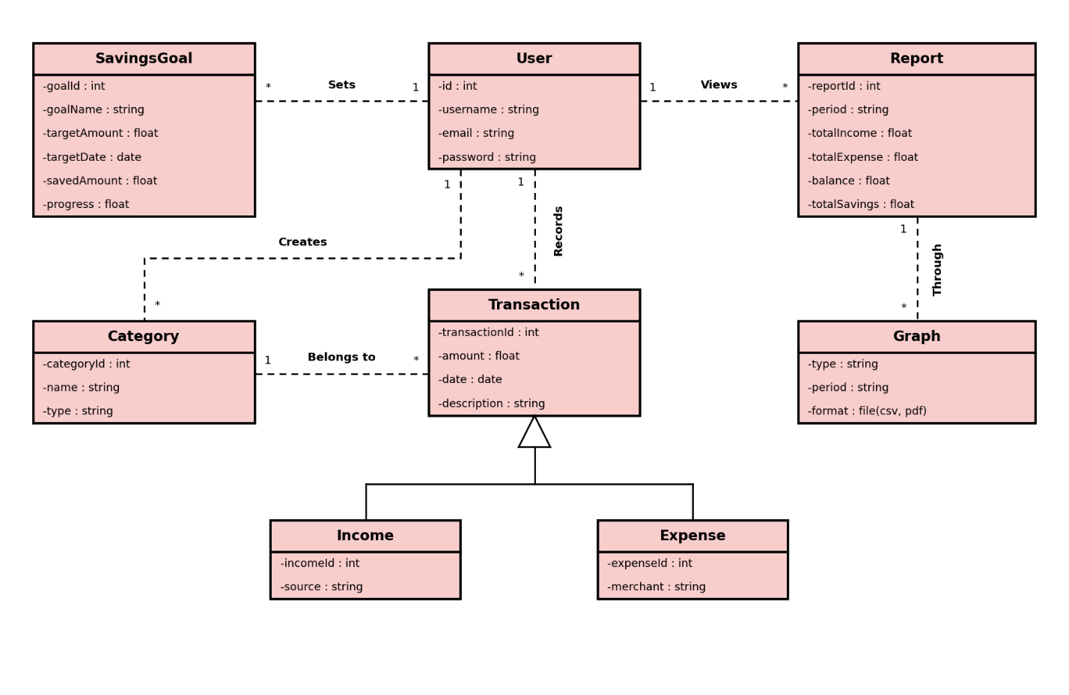

USE CASE DIAGRAM:

